Energy 20-03-2020
Introduction to energy: Energy is an important aspect of human activity. There are several forms of energy like kinetic, potential, thermal, gravitational, sound energy, light energy, elastic, electromagnetic, chemical, and nuclear etc. Major sources of energy are hydro, electric, coal, petrol, natural gas etc, a part of the energy sources also from sun, wind and the tides. Chemical process industries are the largest consumption of energy. The main sources of chemical energy are fuels.
Q- What are chemical fuels? Mention the characteristics of fuel.
Chemical Fuels:
A chemical fuel is a substance containing carbon as main constituent, which on combustion in air or oxygen produces significant amounts of heat and light.
When a fuel undergoes combustion in air, carbon and hydrogen are converted into carbon dioxide and water respectively.
Fuel + O₂ (air) → Combustion products (Ash) + Energy
CHARACTERSTICS OF FUEL:-
- Ignition point: it depends upon hydrogen content, higher is the hydrogen content lower is the ignition point.
- Suitable and controllable combustion rate: combustion of a fuel increases with amount of air available during burning and also depends on physical and chemical properties of the fuel.
- Low smoke emission: higher the volatile content (moisture), higher is the smoke emission. Hence a solid fuel should be dry.
- Low undesirable impurity content: - solid fuels leaves ash as one of the combustible product the amount of which increases with undesirable impurity content.
- Easy transportability, good quality at reasonable rates.
- A good fuel should have high calorific value.
Q- Define calorific value, net and gross calorific value of a fuel. Why NCV is always lower than gross calorific value?
Calorific value is an important parameter of a fuel, which gives information about its heating efficiency. Calorific value of a fuel is the total amount of heat released when a unit quantity (mass or volume) of a fuel is burnt completely in air or oxygen.

Units
For solid and liquid fuels calorific value is normally expressed in calorie per gram (cal/g) or kilocalorie per gram (Kcal/g) or joules per kg (J/Kg) or kilojoules per kg (KJ/Kg).
For volatile liquids and gaseous fuels it is expressed in joules per cubic meter (J/m³), kilojoules per cubic decimeter (KJ/dm³) in SI units.
Calorie is unit of heat which is defined as the amount of heat required to raise1⁰C of the temperature of 1 gm of water.
Types of Calorific value: There are two types of calorific value
1. Higher (HCV) or Gross calorific value
2. Lower (LCV) or Net calorific values
1. Gross (Higher) calorific values:
It is defined as “the amount of heat released when unit quantity of a fuel is burnt completely in air and the combustion products are cooled to room temperature”.
In this the latent heat of water vapor formed is also included. Hence it is always higher than the net calorific value.
2. Net calorific value:
It is defined as “the amount of heat released when a unit quantity of a fuel is burnt completely in air and the products of combustion are let off into the atmosphere”.
In this, water vapours, moisture and gaseous products are not cooled and they are allowed to escape. Hence net calorific value is always lower than gross calorific value.
Net calorific value = Gross calorific value – Latent heat of water vapor formed
= GCV – % H x 0.09 x Latent heat of steam (587Kcal kg⁻¹
or 2453 KJ/kg)
(1 mole of H₂ (2 g) liberates 1 mole of H₂O (18 g)
H₂ + ½ O₂ → H₂O
The mass of water formed is nine times the mass of hydrogen in the fuel)
Q- Describe how calorific value of a solid fuel or non-volatile liquids is determined using Bomb calorimeter
Bomb calorimeter:
Calorific value of solid or non-volatile liquid fuel is determined by a bomb calorimeter.
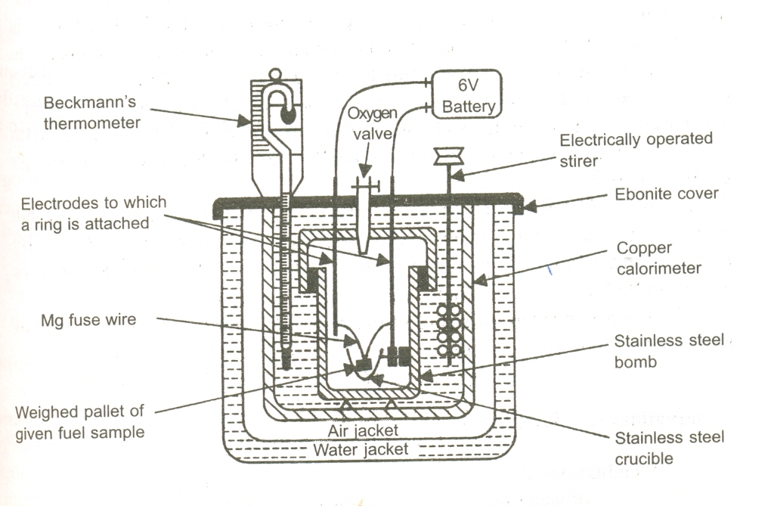

Principle:
A known weight of the sample (solid or less volatile liquid fuel) is burnt completely in excess of oxygen. The liberated heat is absorbed by the surrounding water and the calorimeter. Thus the heat liberated during the combustion of fuel is equal to the heat absorbed by water and copper calorimeter.
Construction:
It consists of a stain less steel air tight sealed cylindrical bomb. The bomb has an inlet value for providing oxygen atmosphere inside the bomb and an electrical ignition coil for the initiation of combustion of fuel. The bomb is placed in a large, well insulated copper calorimeter. The copper calorimeter is equipped with a mechanical stirrer for dissipation of heat and a thermometer to read accurately the temperature rise.
Working:
A known weight of fuel (solid or liquid) about 0.5-1.0 g is placed in a small stainless steel crucible of the bomb. It is placed in copper calorimeter in which known weight of water is added. The water is kept in constant agitation by the mechanical stirrer. The initial temperature of the water is carefully measured. The bomb is filled with oxygen with 20 – 30 atm. pressure and the combustion of fuel is initiated by passing electric current through the ignition coil.
As the sample burns in the bomb, heat is liberated and is absorbed by the surrounding water and the copper calorimeter. The temperature of water gradually increases and attains the maximum value. The maximum temperature (final) is again carefully noted using Beckmann thermometer.

Observation
Weight of the fuel = m kg
Weight of water taken in the calorimeter = W kg
Water equivalent mass of calorimeter = w kg
Initial temperature of water = T₁K
Final temperature of water = T₂ K
Therefore;
Rise in temperature = (T₂-T₁) K
Specific heat of water = S kJ kg⁻¹ ⁰C⁻¹
Higher calorific value, HCV = (W+w) x (T₂-T₁) x S / m
= ………………… KJ/Kg
To determine the water equivalent mass of the calorimeter, the experiment is repeated with a standard fuel like benzoic acid whose calorific value is known and that value is substituted for finding the calorific value of unknown fuel.
Q- What is ‘Straight run gasoline’?
The gasoline which is obtained from first fractionation of crude oil or petroleum is called ‘Straight run gasoline’. Straight run gasoline mainly made up of straight-chain hydrocarbons and sulphur compounds, it has a greater tendency to knock.
Q-What is cracking? Explain with a neat diagram fluidized bed catalytic cracking. List-out the advantages of cracking.
Petroleum is the most important naturally occurring liquid fuel. On primary distillation of petroleum gives only 30% of straight run petrol. This has poor quality and needs blending in order to overcome these difficulties. Hence, the middle oil and heavy oil fractions are cracked to get petrol. The main objective of cracking is the production of more petrol.
Definition: The thermal decomposition of higher hydrocarbon molecules into simpler, low boiling hydrocarbons of lower molecular weights. Cracking process involves breaking (rupture) of carbon-carbon and carbon – hydrogen bonds.
For ex: C₁₀H₂₂ → C₅H₁₂ + C₅H₁₀
n-decane n-pentane n-pentene
BP=174 ⁰C 35 ⁰C 35 ⁰C
Types of Cracking:

There are two types cracking 1. Thermal cracking 2. Catalytic cracking
1. Thermal cracking:
In this method, the heavy oil is subjected to vaporizing at about 700 ^{O}C under high pressure of 20 atmospheres in the absence of air and catalyst. The higher hydrocarbon molecules breakdown into simpler molecules of alkane and alkenes series and hydrogen.
2. Catalytic cracking:
In this method, cracking is carried out in the presence of catalysts at milder conditions (lower temperature and lower pressure).
Catalytic cracking process is two types.
1. Fixed bed catalytic cracking:
2. Fluidized (moving) bed catalytic cracking process:
Out of two, the fluidized bed catalytic cracking has several advantages over fixed bed cracking.
Principle: when a finely divided catalyst is kept in contact with the gaseous fuel in a reaction chamber cracking takes place.
Construction: The process consists of a cracking chamber and a catalytic regenerator connected to each other. It also contains a hot air blower and steam blower. The catalyst used is clay mixed with zirconium oxide in powder form.
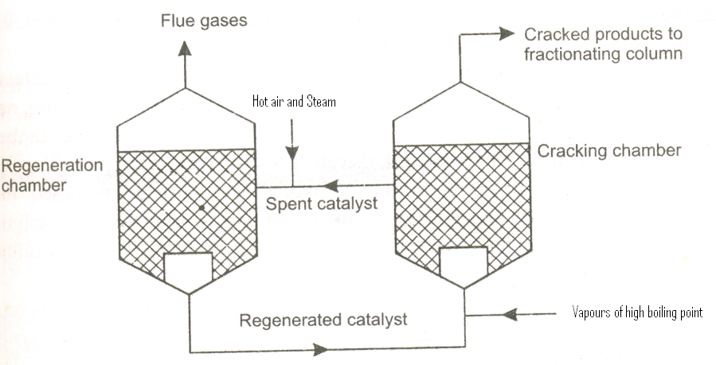

Working: The vapors of high boiling point is mixed with finely powdered catalyst (clay mixed with zirconium oxide in the powder form) and fed into a reactor at 500⁰C and at one atmosphere pressure. Heavy oil vapours are cracked on the surface of the catalyst. The cracked vapours are pass in to the fractionating column where the unconverted oil and gasoline are separated after cooling. After few operations over the catalyst becomes inactive due to adsorption of oil vapors and deposition of carbon on it. The deactivated catalyst is drawn continuously form the bottom of the cracking chamber and transformed in to another chamber called Regeneration chamber. A blast of hot air and stream is passed to burn off carbon deposited on the catalyst and to scrub the oil vapors. The regenerated catalyst is again introduced into the reactor by a current air.
Advantages of the catalytic cracking method:
i) The extent of mixing between catalyst particle and high boiling point vapors is very high, hence it gives larger percentage of gasoline (about 70%)
ii) Petrol has better antiknock characteristic.
iii) The process can be readily controlled.
iv)It also gives other hydrocarbon as by products which are employed in the manufacture of petrochemicals
v) A major advantage of catalytic cracking is that the product obtained contains higher percentage of aromatic hydrocarbons and lower percentage of alkanes.
vi) Catalyst can be regenerated and used it again.
Q- Justify- The catalyst used in catalytic cracking needs regeneration
After few operations the catalyst becomes inactive due to adsorption of oil vapors and deposition of carbon on it. The spent catalyst particles are separated and subjected to regeneration. A blast of hot air and stream is passed to burn off carbon deposited on the catalyst and to scrub the oil vapors.
Q- Justify- Petrol obtained from petroleum (straight – run gasoline) is subjected to reforming
Straight run gasoline obtained from first fractionation of petroleum contains manly straight chain hydrocarbons. As such, it has very low octane rating not greater than 60. But internal combustion engine require gasoline of above 90. Therefore, in order to enhance the quality of petrol ie., to increase the octane number of straight run gasoline, it is subjected for reforming process.

Q-What is reforming? Explain any four principal reactions occurring during the process.
Reforming of petrol: Straight run gasoline mainly made up of undesirable straight-chain hydrocarbons and sulphur compounds. Straight run gasoline has a greater tendency to knock. In order to increase the quality of petrol, it is necessary to subject ‘chemical processing’ methods like reforming.
The process of bringing about structural modifications in the components of straight run gasoline is called Reforming
Reforming process is important in the production of high octane petrol. Reforming reactions are carried either thermally at 500–600⁰C temperature and 85 atm pressure or in the presence of platinum coated on alumina silica base catalyst at about 400 – 500 ⁰C under 15 – 30 atmospheric pressure.
The important reactions involved during the catalytic reforming process are
- Dehydrogenation
- Dehydro cyclization
- Hydrocracking
- Isomerization
1. Dehydrogenation: Removal hydrogen to get unsaturated compounds.
Ex: C₆H₁₂ → C₆H₆ + 3 H₂
Cyclohexane Benzene
2. Cyclisation followed by dehydrogination (Dehydro-cyclization): removal hydrogen and followed by cyclization to produce aromatic hydrocarbons.
CH₃-(CH₂)₄-CH₃ → C₆H₁₂ → C₆H₆ + 3 H₂
n-hexane cyclohexane Benzene
3. Hydrocracking: Converting higher hydrocarbons into lower hydrocarbons by supplying hydrogen in the presence of catalyst.
Ex: CH₃-(CH₂)₅-CH₃ + H₂ → CH₃-CH₂-CH₃ + CH₃-CH₂-CH₂-CH₃
n-heptane propane n-butane
4. Isomerization: The straight chain hydro carbons are converted into branched chain hydrocarbons.
CH₃-(CH₂)₄-CH₃ → CH₃ – CH-CH₂-CH₂-CH₃
│
CH₃
n-hexane 2-Methyl pentane
Q-What is compression ratio? Explain the meaning of knocking in IC engines. Explain its mechanism.
Compression ratio: The ratio of the gaseous volume in the cylinder at the end of the suction – stroke to the volume at the end of compression of the piston (V2/V1). As compression ratio increases efficiency of internal combustion engines also increases, but beyond a certain compression ratio the efficiency remain same or drastically drops down to zero might be due to knocking (Fig A)
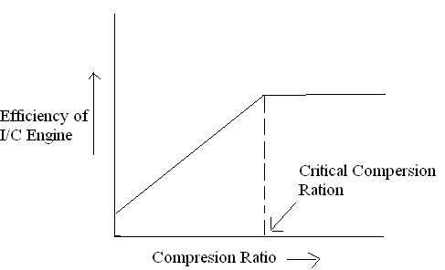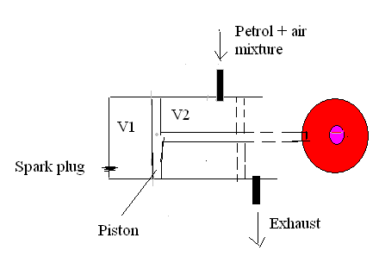
Fig. A Fig. B
Knocking and its mechanism:
When gasoline (with high octane number) and air mixture is injected in to an Intenal combustion (IC) engine chamber (Fig B). Petrol and air mixture is compressed in the cylinder in the compression stroke, the mixture is ignited by applying an electric spark plug. The flame front travels at the speed of 20-25 ms⁻¹ and the power production is smooth. However, if the gasoline of low octane rating, fuel-air mixture burns instantaneously (explosive combustion) and produces flame propagation at the rate of 2500 ms^{-1,} This process is accompanied by a sharp knock in the engine and black smoke is liberated out of the engine. This gives a thermal shock wave in cylinder resulting in production of a rattling sound, this is called knocking. It is defined as “the production of a shock wave in an internal combustion engine as a result of an explosive combustion of petrol – air mixture as a result to increase in the compression ratio, beyond a certain value, leading to a rattling sound”
Knocking of petrol is mainly due to nature of the constituents present in the gasoline.

Mechanism:
Normal combustion: Under normal conditions, there is smooth combustion of fuel with oxygen as follows.
C₆H₁₄ + 19_{1/2}O₂ → 6CO₂ + 7H₂O
Explosive combustion: But in knocking reaction, few hydrocarbons of the fuel combine with oxygen and activate them to produce peroxides which are highly unstable, explosive in nature and decomposes readily to give a number of gaseous compounds. This gives rise to sudden pressure waves which knock against the engine walls.

C₂H₆ + O₂ → CH₃-O-O-CH₃
Fuel Ethane peroxide

CH₃-O-O-CH₃ → CH₃CHO +H₂O
Acetaldehyde
CH₃CHO → HCHO + CO₂ + H₂O
Formaldehyde
HCHO + O₂ → CO₂ + H₂O

Knocking of the petrol is depends on nature of the constituents present in the gasoline, engine design, location of plug and running condition. The tendency of fuel constituents to knock is in the following order. Straight - chain paraffins > branched - chain paraffins (iso-paraffins) > olefins > cycloparaffins (naphthalenes) > aromatics
Q- What are the ill effects of knocking? What are the remedial methods to reduce knocking tendency of IC engine?

Affects of Knocking: it causes the following effects
  - Produces undesirable rattling sound
  - Decreases efficiency of engine and power out put
  - Increases the fuel consumption
  - Engine wear i.e., mechanical damages to spark plugs, piston and other metallic parts due to overheating
  - The driving becomes rather unpleasant
  - Increase fuel consumption.

Prevention of Knocking: Knocking of the IC engines can be controlled by the following methods

1. by using suitable change in engine design
2. by using high octane rating gasoline
3. by using critical compression ratio
4. by using anti-knocking agents
Q-Discuss varius antiknocking agents used in reduction of knocking.
Knocking can be reduced by adding some specific compounds to the fuel which are called as anti-knocking agents. The commercial anti-knocking agents are (a) Tetra ethyl lead, TEL [(C₂H₅)₄Pb], (b) Tetra methyl lead, TML [(CH₃)₄Pb], (c) Mixed ethyl methyl lead. Among the anti-knocks TEL is widely used agent. Because, it is cheap and more effective in increasing the octane rating of the fuel.
During the combustion TEL forms Pb and PbO. These species act as free radicals chain inhibitors and thus curtail the propagation of explosive chain reaction and thereby minimizing the knocking. However, if TEL is used, the species Pb and PbO may get deposited on engine parts and causes mechanical damage or change the compression ratio. Hence, TEL is always used along with ethylene dichloride or dibromide. These convert less volatile Pb and PbO to more volatile PbCl₂ and PbBr₂ which escape into air along with exhaust gases.
Nowadays methyl tertiary butyl ether (MTBE), ethyl tertiary butyl ether (ETBE), methanol, ethanol are used as antiknocking agents, which contains oxygen for combustion of petrol. This reduces the formation of peroxy compounds and hence knocking will be reduced.
Q- Justify, TEL is always used along with ethylene di-bromide, as an antiknocking agent.

During the combustion TEL forms Pb and PbO. These species act as free radicals chain inhibitors and thus curtail the propagation of explosive chain reaction and thereby minimizing the knocking. However, if TEL is used, the species Pb and PbO may get deposited on engine parts and or change the compression and leads to knocking. Hence, TEL is always used along with ethylene dichloride or dibromide. These convert less volatile Pb and PbO to more volatile PbCl₂ and PbBr₂ which escape into air along with exhaust gases.
Q- Explain the terms octane and cetane number.
Octane number: The knocking characteristics of petrol sample are described by the octane number or knocking value. Two hydrocarbons namely Isooctane (2, 2, 4-tri methyl pentane) and n-heptane (C₇H₁₆) are specified as standards. Isooctane is a branched hydrocarbon has the least knocking tendency and its octane number is arbitrary fixed as 100. n-heptane, a straight line hydrocarbon, has the higher tendency to knock and is assigned to zero. In general, straight chain hydrocarbons have low octane number and those with branched chain have high value. Higher the octane number lower is the tendency to knock and better is the quality of petrol. The petrol whose octane number is to be determined is compared with reference mixture of isooctane and n-heptane.
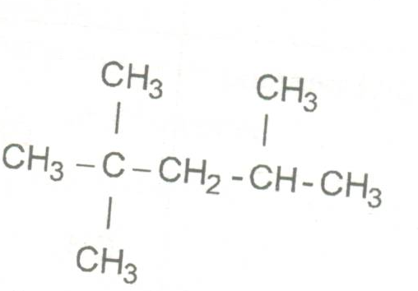
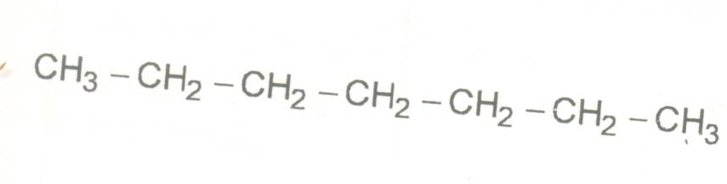 →

n-heptane iso-octane (2,2,4 - trimethy pentane)
Octane No.: Zero Octane No.: 100
Octane number can be defined as ‘the percentage of isooctane present in a standard mixture of isooctane and n-heptane which knocks at the same compression as the petrol being tested’. For ex: The octane number of automobile petrol is found to be equivalent that of a mixture containing 70% isooctane and 30% n-heptane. Its octane number is said to be 70.
Octane numbers of some hydrocarbons:
Hydrocarbon name Octane number
n-heptane 0.0
3-methyl hexane 52
3-ethyl pentane 65
2,3 dimethyl pentane 91
2,2,4-Trimethyl pentane 100
Benzene 118
Cetane number:
A diesel engine functions differently compared to IC engine. In IC engine fuel is mixed with air and then compressed before an electric spark ignites the mixture. In a diesel engine, only the air is compressed, the fuel is then injected into the cylinder filled with compressed air. The heat (500 ºC) from the compressed air ignites the fuel without the aid of an electric spark ignition. The main requirement of diesel engine fuel is that it shuld not have ignition delay. Whereas for IC engine fuel ignition delay is required. Diesel knocking is the rattling sound emitted form a running diesel engine.
In order to evaluate the quality of diesel, an arbitrary cetane scale is developed by their knocking characteristics. Two hydrocarbons namely Cetane or hexadecane (C₁₆H₃₄) and α -methylnaphthalene are specified as standards. Since cetane is a straight chain alkane which ignites readily (low ignition delay) and its Cetane number is arbitrarily fixed as 100. On the other habd α -methylnaphthalene is an aromatic hydrocarbon which has long ignition delay therefore its Cetane number is arbitrarily fixed as zero.
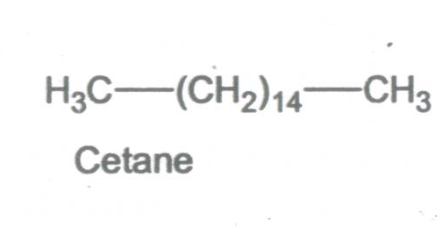
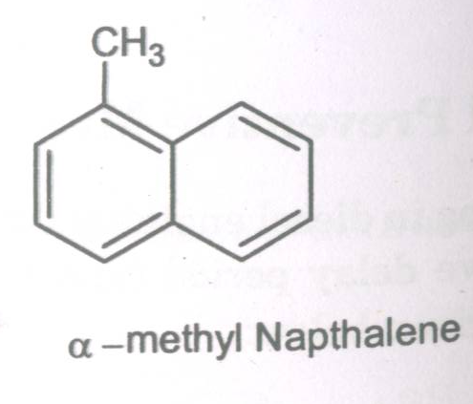

Cetane No.: 100 Cetane No.: Zero
Cetane number can be defined as the percentage of hexadecane (n-Cetane) present in a standard mixture of cetane and α-methylnaphthalene (an aromatic) which knocks at the same compression ratio as the diesel being tested. For ex: The cetane number of automobile diesel is found to be equivalent that of a mixture containing 70% hexadecane and 30% α-methylnaphthalene, its cetane number is said to be 70.
Q. What is biodiesel? How it is synthesized. Mention applications.
Biodiesel is a liquid fuel, which is a mixture of fatty acid alkyl esters, can be produced not only from plant oils, such as coconut oil, palm oil and soybean oil, but also from animal fats or recycled cooking oil and greases.
Reaction (Missing)

CH2-C00R1 +3 CH3OH ------------------→ CH3-C00H +CH20H
| |
CH2-C00R2 CH20H
| |
CH2-C00R3 CH20H
Synthesis of biodiesel: it can be produced by the trans-esterification of the vegetable oil or animal feed stock. Trans-esterification is a process of combining triglyceride oil with methanol or ethanol in the presence of NaOH (catalyst) at 60 ºC for a period of 1-8 hours. The most commonly used alcohol is methanol to produce an ethyl ester biodiesel.
- Advantages of bio-diesel:
- It has 11 % oxygen by weight and no sulphur
- It is safe to store and has a high flash point
- It has greater cetane number than diesel fuel
- 1% of biodiesel increases lubricity by up to 30 %
- It lowers toxic emissions and particulate matter
- The calorific value of biodiesel is about 37.27 MJ/L. This is 9% lower than regular petro-diesel.
(vii) Variations in biodiesel energy density is more dependent on the feedstock used than the production process. Still these variations are less than for petro-diesel.
(viii) It has been claimed biodiesel gives better lubricity and more complete combustion thus increasing the engine energy output and partially compensating for the higher energy
Applications:
- Biodiesel has combustion property very similar to those of petroleum diesel, and can replace it.
- Biodiesel can be used as a fuel for vehicles in its pure form, but it is usually used as a petroleum diesel blend to reduce levels of particulates, carbon monoxide, hydrocarbons and air toxins from diesel-powered vehicles.
- Biodiesel is used in electricity generators
- Used as an alternative in diesel engines with different blends with petrodiesel.
- Biodiesel’s superior lubricity helps reduce engine wear
Question bank for Energy Chapter

1. What is fuel? Describe how calorific value of a solid fuel is determined using Bomb calorimeter 2. Define net and gross calorific value of a fuel. Why Gross calorific value is greater than Net calorific value.
3. What is cracking? Explain with a neat diagram fluidized bed catalytic cracking
4. What does knocking in IC engines mean? Explain its mechanism.
5. What is reforming? Explain any four principal reactions occurring during the process.
6. Explain the terms octane and cetane number.
7. What are anti-knocking agents? Discuss how Knocking is minimized by using antiknocking agents?
8. What is biodiesel? How it is synthesized: Mention its advantage and applications.
9. Numericals on HCV and LCV
Problem: 0.8g of a coal sample when burnt in a bomb calorimeter showed a rise in temperature of 8.2ºC. Calculate the calorific value of coal sample.
Given - Specific heat of water = 4.2 KJ Kg^{-1 o}C ^{–1}
- Water equivalent of calorimeter = 2.2 Kg.
_ Weight of water 700 g
Problem: When 0.935 g of a fuel on complete combustion in air increased the temperature of 1365 g of water by 2.4 ⁰C. Calculate HCV of the fuel it the water equivalent mass of the calorimeter is 135 g. specific heat of water 4.187 kJ kg⁻¹ k⁻¹
Problem: From the following data calculate the rise in temperature of 2560 g of water, if 0.9 g of coal is completely burnt in a bomb calorimeter whose water equivalent mass is 440 g. The HCV of coal is 34450.6 kJ kg⁻¹ k⁻¹ and specific heat of water is 4.187 kJ kg⁻¹ k⁻¹.
Given; x = 0.935 X 10⁻³ kg,
W = 2560 X 10⁻³ kg,
w = 440 X 10⁻³ kg,
HCV = 34450.6 kJ kg⁻¹ k⁻¹
(T₂-T₁) = ?
Problem: Calculate the water equivalent mass of the calorimeter when 1.442 g of benzoic acid (Fuel) was burnt, gave a rise of 2.93 K in temperature of 1040 g of water. Specific heat of water 4.187 kJ kg⁻¹ k⁻¹
Problem 6. Calculate the Gross calorific value of a sample of coke from the following data:
Mass of coke = 0.8 X 10⁻³ kg; Water equivalent of calorimeter = 0.423 kg;
Mass of water: 1.3 kg; Specific heat of water = 4.187 KJkg⁻¹K⁻¹;
Rise in temperature = 1.8 K
Problem: Calculate the percentage of Hydrogen in the coal sample from the following data:
Net calorific value of a coal sample 47138.2 KJ/Kg
Mass of coal sample taken = 8.5x10⁻⁴Kg
Mass of water taken in the calorimeter = 3.5Kg
Water equivalent of calorimeter = 0.5 Kg
Initial temperature of water in calorimeter = 298 K
Final temperature of water in calorimeter = 300.5 K
Percentage of Hydrogen in the coal sample = 2.5
Latent Heat of Steam = 2455KJ/Kg.
Specific heat of Water = 4.187 KJkg⁻¹K⁻¹
Problem: 128 g of a solid fuel was burnt in a bomb calorimeter. Calculate the gross calorific value, if weight of water taken in the calorimeter is 1.2 kg, water equivalent of calorimeter is 0.2 kg and raise in temperature is 4 K, Calculate the weight of water produced by the fuel if hydrogen percentage in it is 3 (Specific heat of water = 4.2KJ/kg)
Problem - When 0.625 g of a coal sample was burnt in air increased the temperature on 2065 g of water by 2.1 ºC. Calculate HCV & LCV of the fuel. Given: Water equivalent o Calorimeter = 135 g and % H2 = 5, Latent heat of stem = 587 cal/g.
*************

